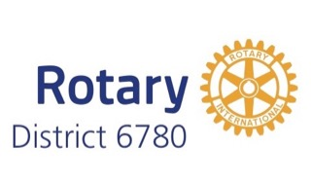 | District Grant Timeline  2023-2024 | 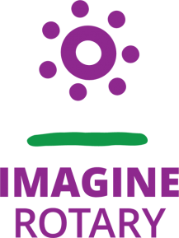

- Project Planning
  - President-elect year: the club identifies its District Grant project for Rotary Year 2023-2024.

- Club Qualification
  - Two club members (President-elect and project lead recommended) attend district grant qualification training during Rotary year 2022-2023.
  - The Club Memorandum of Understanding and Club Qualification Plan (one combined document) must be submitted for the grant proposal to be considered (may be submitted with the application).

- Application
  - Applications for the District Grants are accepted between October 8, 2022, and January 31, 2023.
  - Grants will be reviewed, and approvals announced beginning in February 2023.

- Funding
  - Clubs may expect to get a grant for half of the project cost, up to the club allocation.
  - Clubs should immediately notify the District Grant team if their project cannot be completed – this allows the funds to be reallocated to clubs with pending projects.

- Execution
  - Work on club projects may not begin until the club has been notified by the District that The Rotary Foundation has approved the District 6780 district grant package for 2023-2024! (This should occur by June 1, 2023.)
  - Target date for grant completion: March 31, 2024

- Progress Report
  - A progress report is due on October 1, 2023.

- Completion
  - The Project, except for the final report, should be completed by March 31, 2024.

- Closing Report
  - A final report with receipts should be submitted within two months of completion of the project, but no later than May 31, 2024.
  - Reimbursement by the District grant will occur after the final report is approved and the funds have been transferred to the District by The Rotary Foundation

